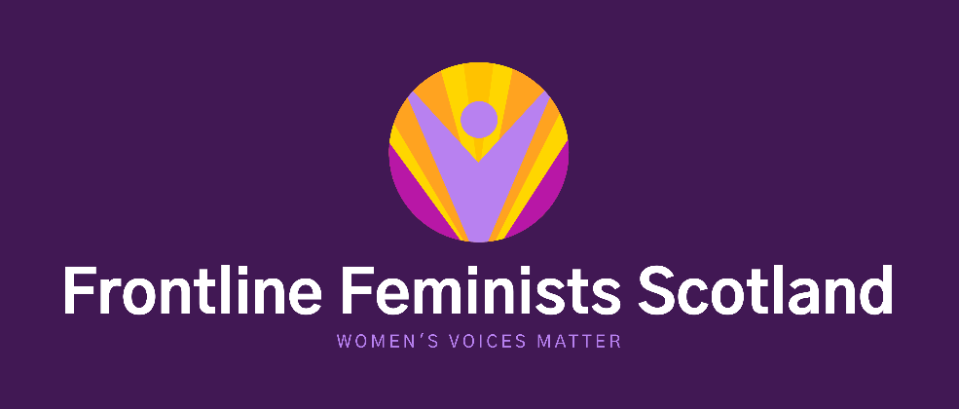

GROUP MEMBERSHIP FORM

Lead Name: __________________________________________________________________________

Address: __________________________________________________________________________

__________________________________________________________________________

Tel: _____________________________ Email: ______________________________________

Facebook: _____________________________ Twitter: _____________________________________

Frontline Feminists Scotland is committed to amplifying women’s voices and campaigning for women’s rights. In order for us to do this we welcome any woman to join us who share our beliefs and values;

- Women experience various issues and forms of sex-based discrimination.
- Feminism is a political theory, as well as a way of life, it has had a significant impact on increasing women’s opportunities, and should be recognised as having a vital contribution to progressing women’s rights further.
- There is a global pandemic of male violence against women, including commercial sexual exploitation, as such this should be a priority for all government bodies, international, national and local. All women deserve to live a life free from fear.
- Every woman is entitled to express herself and her reality, should be actively encouraged to do so, be listened to and believed when she does.
- Women must be at the centre of their support and have a right to single sex service provision.

Please write a short paragraph about your group and why you would like to be affiliated to Frontline Feminists Scotland.

Keep in Touch!

Membership forms should be returned to our email address: frontlinefeministsscotland@gmail.com

Please link in with our social media on
Facebook: @FrontlineFeministsScotland Twitter: @frontlinefemin1
Website: www.frontlinefeministsscotland.com

Organisational Information only

Membership No: _____________ Membership Confirmed:

