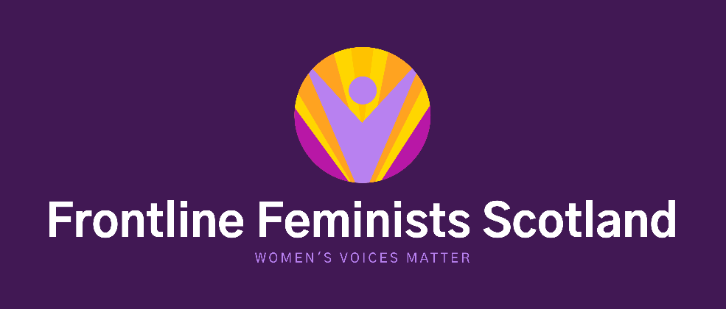

BELIEFS AND VALUES

Frontline Feminists Scotland is committed to amplifying women’s voices and campaigning for women’s rights. In order for us to do this we welcome any woman to join us who share our beliefs and values;

- Women experience various issues and forms of sex-based discrimination.
- Feminism is a political theory, as well as a way of life, it has had a significant impact on increasing women’s opportunities, and should be recognised as having a vital contribution to progressing women’s rights further.
- There is a global pandemic of male violence against women, including commercial sexual exploitation, as such this should be a priority for all government bodies, international, national and local. All women deserve to live a life free from fear.
- Every woman is entitled to express herself and her reality, should be actively encouraged to do so, be listened to and believed when she does.
- Women must be at the centre of their support and have a right to single sex service provision.

